Read Me Documentation
This documentation is about how to deploy the contract via Remix and how to test or use it with different accounts. At the end, a flow figure is displayed.
How to use
The following steps show how to use this contract:
- Select an account to deploy the contract and set the required seller deposit amount as follows,
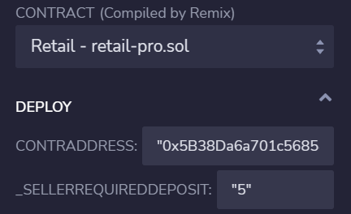
- Switch an account and register as buyer as follows,
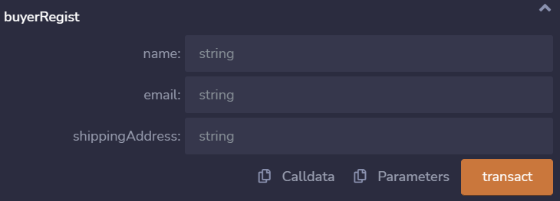
- Switch an account and register as seller as follows,
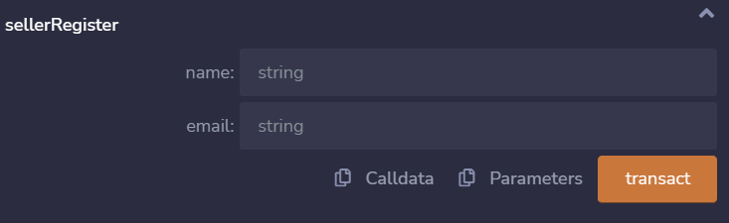
- The seller add product info as follows,
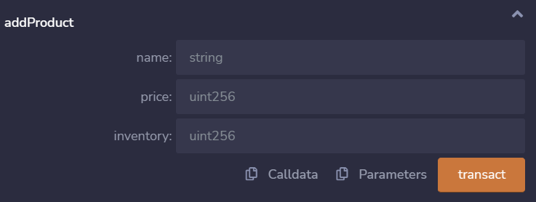
- Switch to buyer account and view product info as follows,
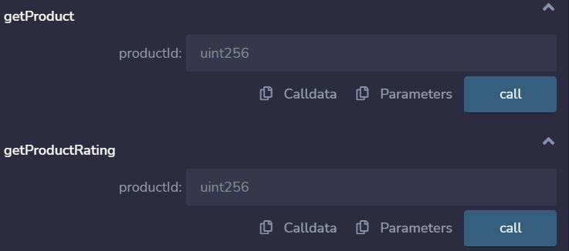
(PS: here you should know the product ID)
- The buyer buys the product by initiating the transaction as follows,
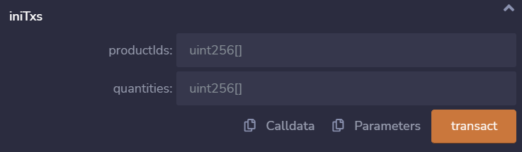
- Only buyer account can confirm the transaction as follows, the seller gat paid after the transaction finished.
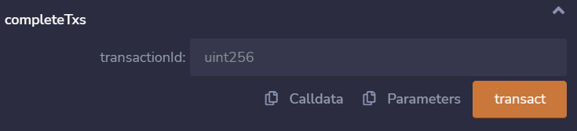
(PS: here you should know the transaction ID)
- Buyer can rate the product as follows,
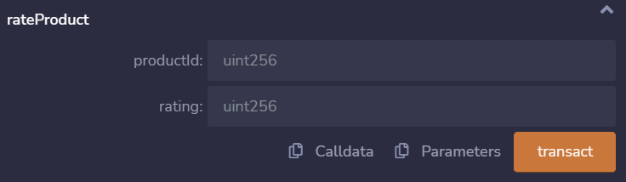
- Buyer can ask for return the product as follows,
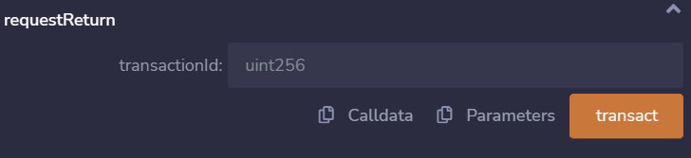
- Switch to seller account to approve the return as follows,
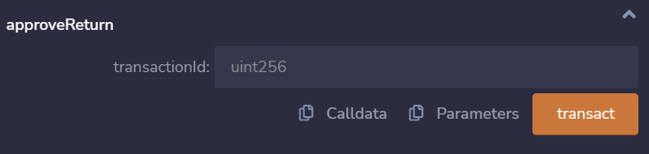
- Buyer can update their info as follows,
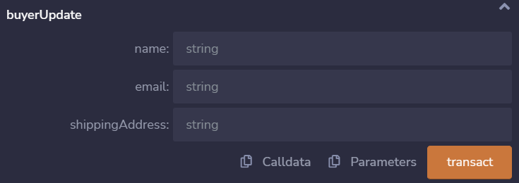
Flow diagram of the contract
The following figure shows flow of this smart contract:
